

# AMERICAN INTERNATIONAL UNIVERSITY- BANGLADESH (AIUB)

**Introduction to Electrical Circuit**

**FALL 2023-2024**

**Section: L, Group: 07**

# LAB REPORT ON

# *Study of Combination of Series-Parallel Circuits and Verification of ∆−Y or Y−∆ Conversion Introduction*

# Supervised By

## MD. SHAHARIAR PARVEZ

|  |  |
| --- | --- |
| **Name** | **ID** |
| **1.MD. Abdullah** | **22-48065-2** |
| **2.Azmir Islam Kafi** | **22-47981-2** |
| **3.Mohammad Ansar Uddin** | **22-47975-2** |
| **4.Chinmoy Guha** | **22-48056-2** |
| **5.Suvra Chakraborty** | **22-48067-2** |

### 

***Introduction:***

Series-parallel networks are complex electrical circuits that incorporate both series and parallel circuit elements. In these networks, we can analyze series portions using Kirchhoff's Voltage Law (KVL) and the Voltage Divider Rule (VDR), while parallel sections can be evaluated using Kirchhoff's Current Law (KCL) and the Current Divider Rule (CDR). When dealing with a combination of series and parallel components within a network, we can employ a combination of KVL, KCL, VDR, and CDR to solve it.

In the process of solving networks with a substantial number of branches using Kirchhoff's Laws, one may encounter challenges due to the need to handle multiple simultaneous equations. However, for simplification purposes, particularly in intricate networks, we can systematically replace delta meshes with equivalent Y systems and vice versa. This simplification technique aids in making the analysis of complex networks more manageable. And this is exactly what we are going to verify in this experiment.

***Apparatus***

1. Trainer Board
2. AVO meter or Multimeter
3. DC source
4. Resistors
5. Connecting Wires

***Circuit Diagram:***

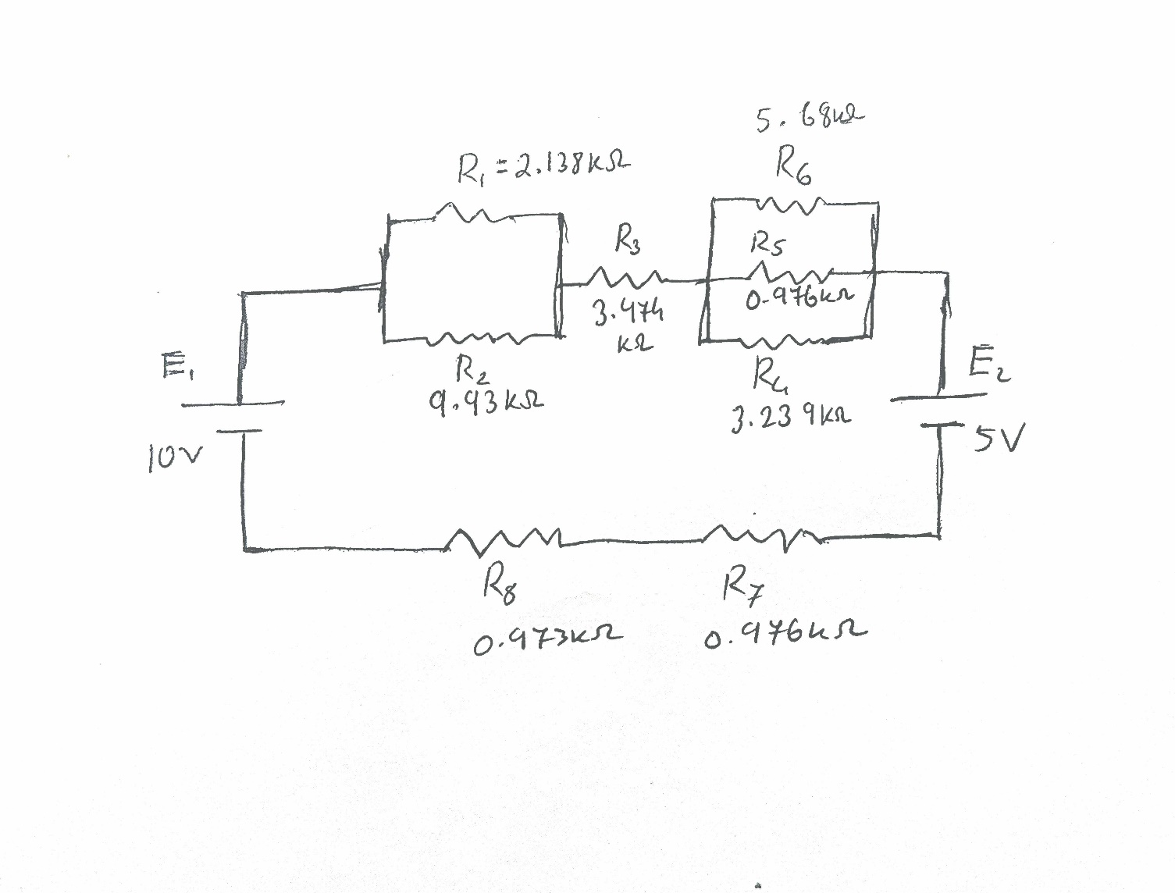

Figure: Diagram 1

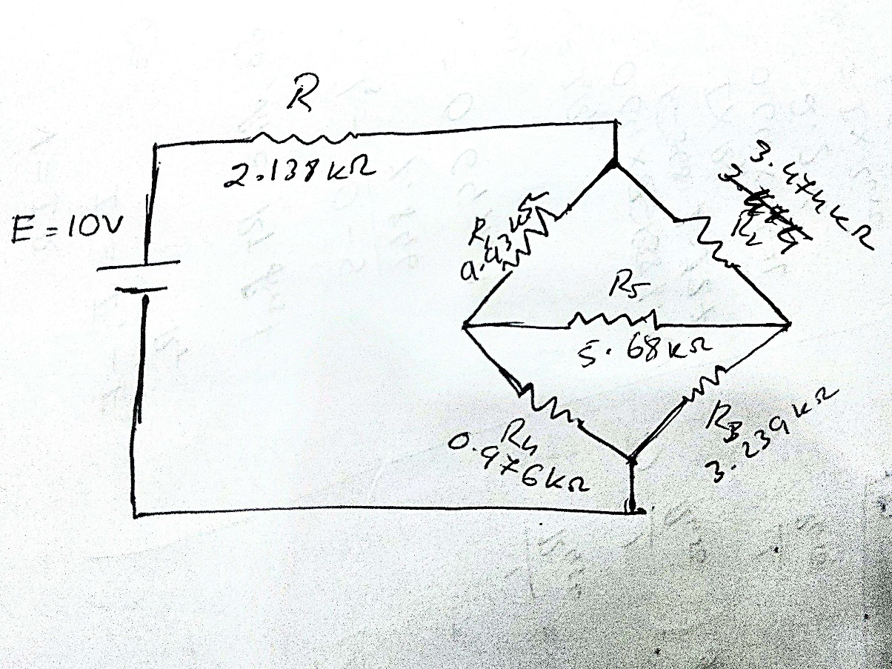

Figure: Diagram 2

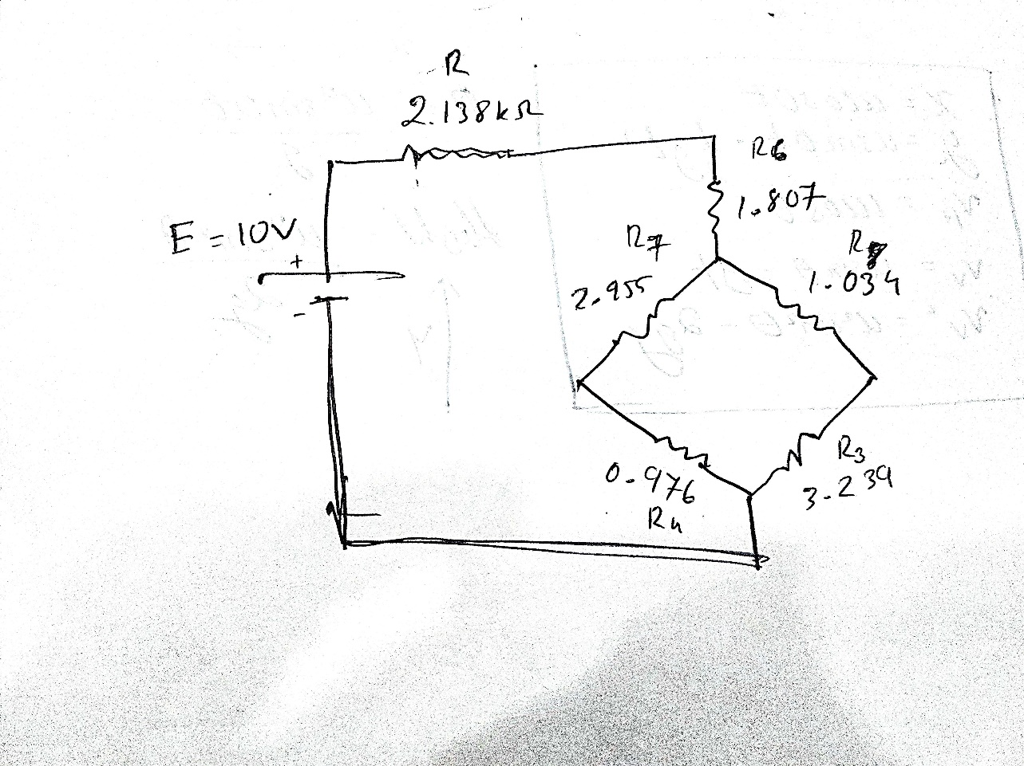

Figure: Diagram 3

***Experimental Procedure:***

We connected the circuit as shown in the Diagram 1 and the potential difference across each resistance and current of each branch was measured. After that we input the measured data into Table 1.

Next, we connected the circuit as shown in Diagram 2, and the potential difference across each resistance and current of each branch was measured. The total current flow was also taken into account and measured using the multimeter, and the equivalent resistance of the total circuit was determined. Then we input that data into Table 2.

The delta connection of resistors R1, R2, and R5 was then converted into a wye connection of R6, R7 and R8 as shown in Diagram 3. The voltages across each resistance, current through each branch, and equivalent resistance of the total circuit was measured and the corresponding data was set into Table 3.

Then we did a simulation of all 3 circuits using Ni Multisim Software.

**Table: 1*-***  for series-parallel connection

|  |  |  |  |  |  |  |  |  |  |  |  |
| --- | --- | --- | --- | --- | --- | --- | --- | --- | --- | --- | --- |
| Calculated Value | | | | | | Measured Value | | | | | |
| I | VR12 | VR3 | VR456 | VR7 | VR8 | I | VR12 | VR3 | VR456 | VR7 | VR8 |
| 640µA | 1.12v | 2.2v | 0.42v | 0.62v | 0.62v | 680**µA** | 1.074v | 2.122v | 0.404v | 0.659v | 0.659v |

**Table: 2-** Data table for delta connection

|  |  |  |  |  |  |  |  |  |  |  |  |
| --- | --- | --- | --- | --- | --- | --- | --- | --- | --- | --- | --- |
| VR | VR1 | VR2 | VR3 | VR4 | VR5 | IR | IR1 | IR2 | IR3 | IR4 | IR5 |
| 3.52v | 5.59v | 3.81v | 2.56v | 0.825v | 1.74v | 1.668mA | 0.55mA | 1.11mA | 0.84mA | 0.91mA | 0.32mA |

**Table: 3-** Data table for wye connection

|  |  |  |  |  |  |  |  |  |  |  |  |
| --- | --- | --- | --- | --- | --- | --- | --- | --- | --- | --- | --- |
| VR | VR3 | VR4 | VR6 | VR7 | VR8 | IR | IR3 | IR4 | IR6 | IR7 | IR8 |
| 3.568v | 2.59v | 0.848v | 3.015v | 2.57v | 0.827v | 1.66  mA | 0.79  mA | 0.86  mA | 1.66  mA | 0.86  mA | 0.79  mA |

***Calculation:***

Given,

R1 = 2.138 kΩ

R2 = 9.93 kΩ

R3 = 3.474 kΩ

R4 = 3.239 kΩ

R5 = 0.976 kΩ

R6 = 5.68 kΩ

R7 = 0.976 kΩ

R8 = 0.973 kΩ

***For Table 1,***

R12 = 1.761 kΩ

R456 = 0.662 kΩ

Total Resistance, Rt = R12+R3+R456+R7+R8= 7.847 kΩ

I = (E1-E2)/Rt = 0.64mA

Therefore, according to V=IR,

VR12 = 1.127v  
 VR3 = 2.2v

VR456 = 0.424v

VR7 = 0.624v

VR8 = 0.622v

***For Table 2,***

R = 2.138 kΩ

R1 = 9.93 kΩ

R2 = 3.474 kΩ

R3 = 3.239 kΩ

R4 = 0.976 kΩ

R5 = 5.68 kΩ

VR = 3.52v

VR1 = 5.59v

VR2 = 3.81v

VR3 = 2.56v

VR4 = 0.825v

VR5 = 1.74v

So,

𝑉 3.52𝑣

𝐼𝑅 = = 1.668𝑚𝐴

𝑅 2.138Ω

𝑉𝑅1

𝐼𝑅1 = = 0.562𝑚𝐴

𝑅1 𝑉𝑅2

𝐼𝑅2 = = 1.106𝑚𝐴

𝑅2

𝑉𝑅3

𝐼𝑅3 = = 0.79𝑚𝐴

𝑅3

𝑉𝑅4

𝐼𝑅4 = = 0.868𝑚𝐴

𝑅4

𝑉𝑅5

𝐼𝑅5 = = 0.3066𝑚𝐴

𝑅5

ΔY Conversion:

|  |
| --- |
| Given,  R1 = 9.93 kΩ  R2 = 3.474 kΩ  R5 = 5.68 kΩ |

𝑅6 = ( 𝑅1 × 𝑅2) / (𝑅1 + 𝑅2 + 𝑅3 ) = 1.807 kΩ

𝑅7 = ( 𝑅1 × 𝑅5) / (𝑅1 + 𝑅2 + 𝑅3 ) = 2.955 kΩ

𝑅8 = ( 𝑅2 × 𝑅5) / (𝑅1 + 𝑅2 + 𝑅3 ) = 1.034 kΩ

VR = 3.568 v

VR3 = 2.59 v

VR4 = 0.848v

VR6 = 3.015 v

VR7 = 2.57 v

VR8 = 0.827v

𝑉

𝐼𝑅 = = 1.66𝑚𝐴

𝑅 𝑉𝑅3

𝐼𝑅3 = = 0.79𝑚𝐴

𝑅3 𝑉𝑅4

𝐼𝑅4 = = 0.86𝑚𝐴

𝑅4

𝑉𝑅6

𝐼𝑅6 = = 1.66𝑚𝐴

𝑅6

𝑉𝑅7

𝐼𝑅7 = = 0.86𝑚𝐴

𝑅7

𝑉𝑅8

𝐼𝑅8 = = 0.79𝑚𝐴

𝑅8

***Result:***

For Delta connection:

VR = 3.52v

IR =1.67mA

For Δ𝑌 connection:

VR =3.57v

IR =1.66mA

***Simulation:***

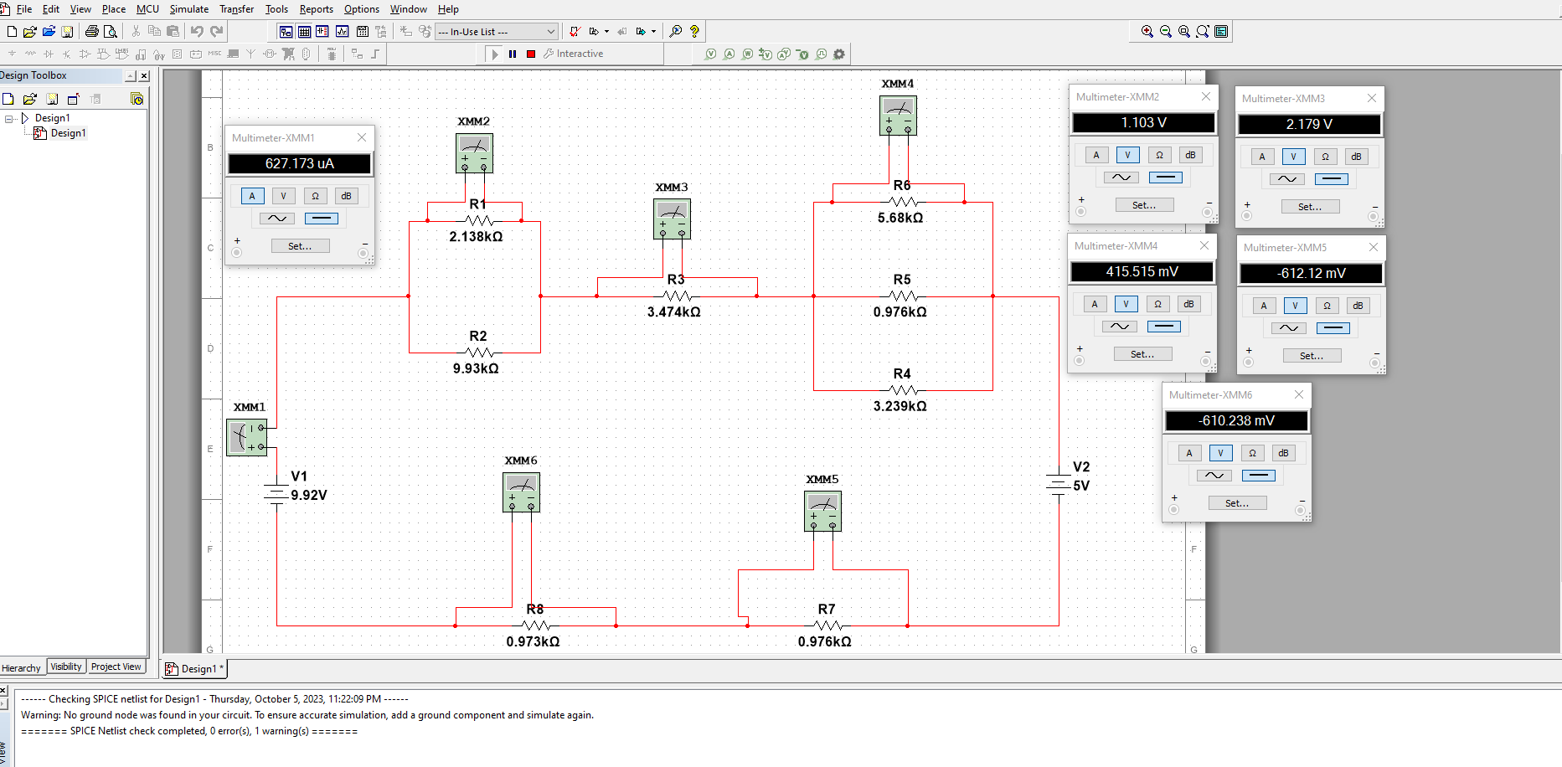

***For table 1: Total Current and Voltage across the Resistors.***

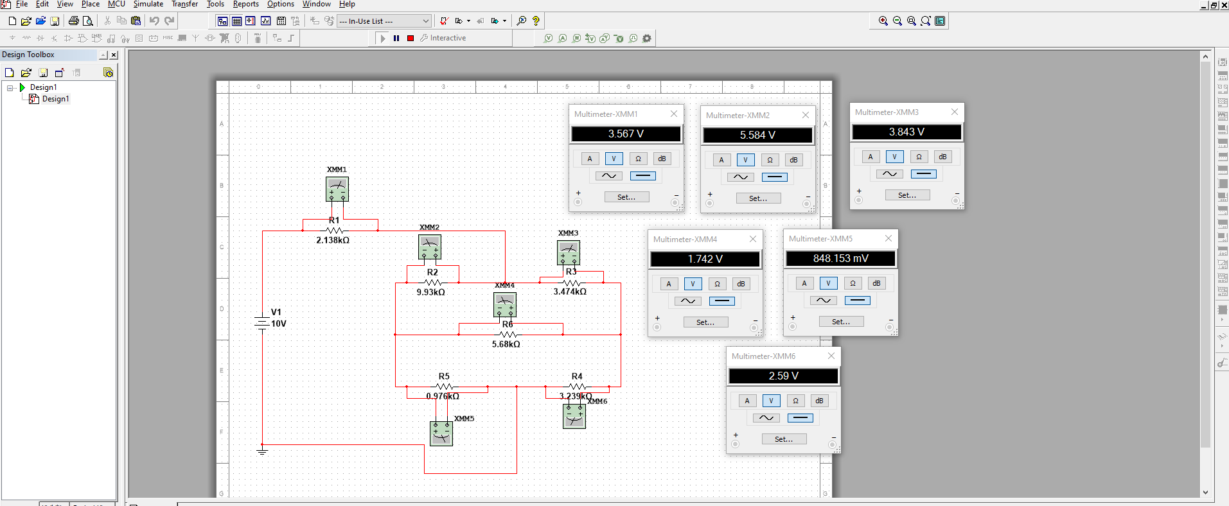

***For table 2: Voltage across the Resistors.***

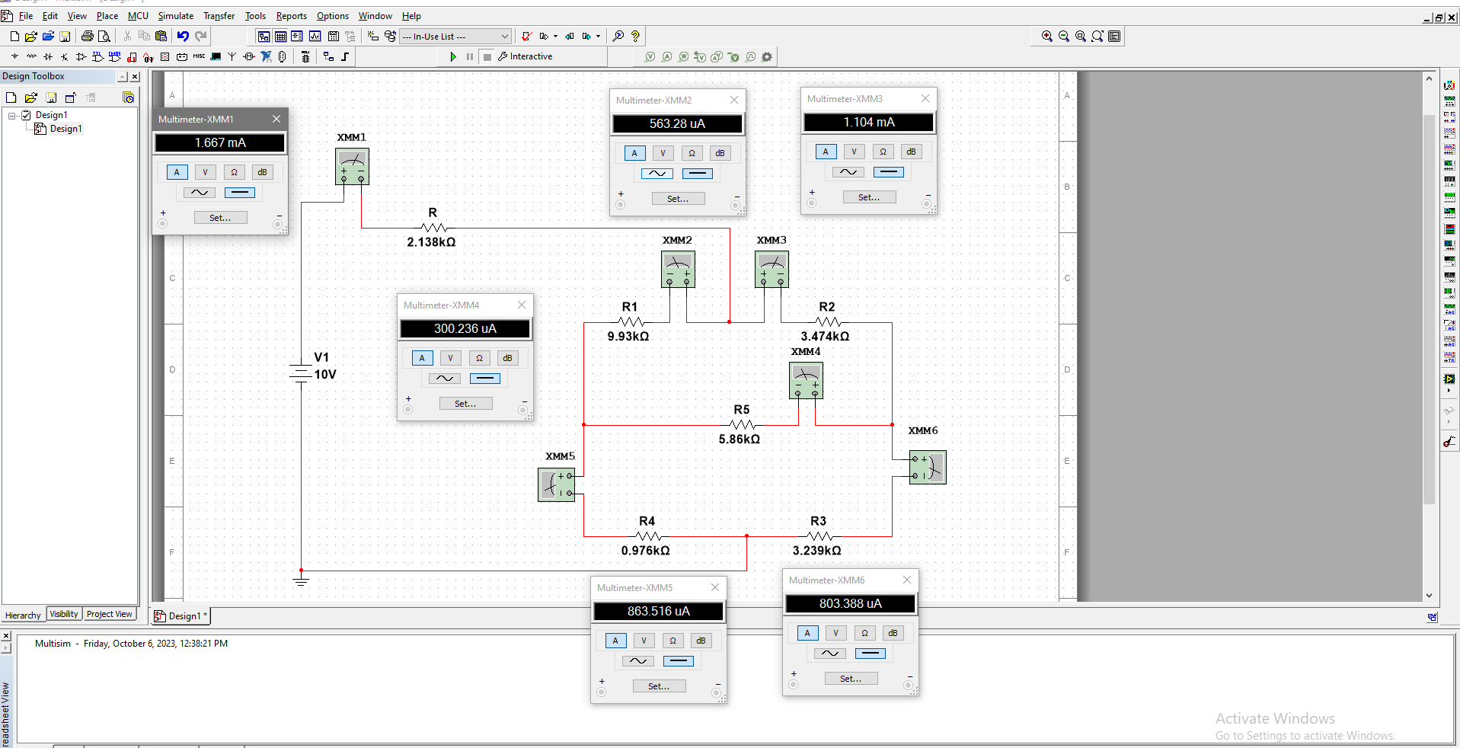

***For table 2: Current flow in every branch of the circuit.***

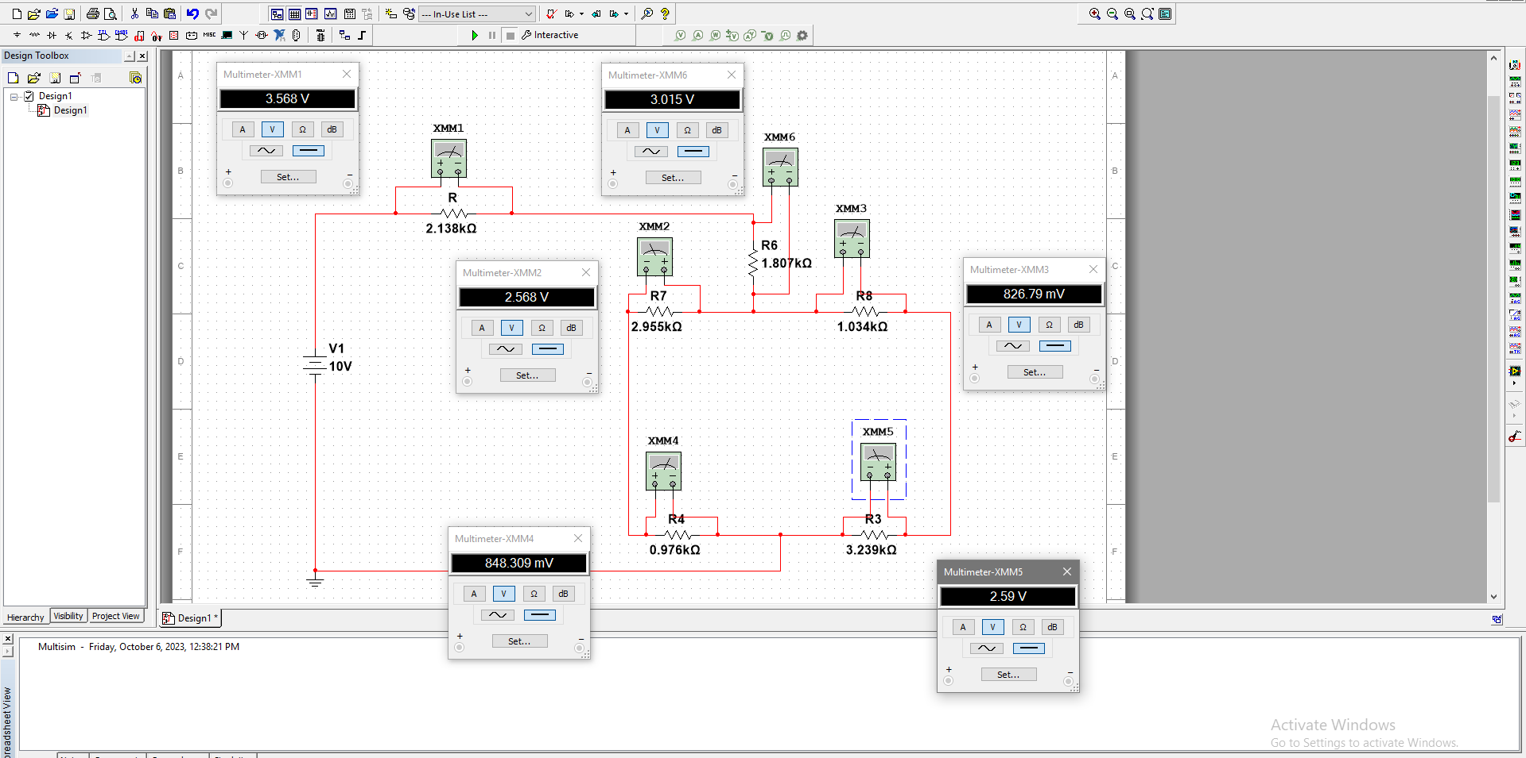

***For table 3: Voltage across the Resistors.***

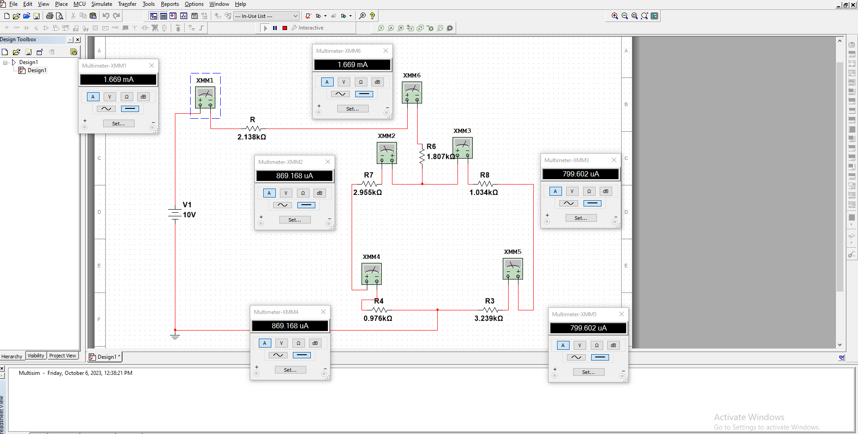

***For table 3: Current flow in every branch of the circuit.***

***Discussion & Conclusion:***

We set up the circuit in the breadboard according to diagram 1 and 2 and measured the values in table 1. Then we calculated the same values using formulae and also used Ni Multisim software to simulate these circuits. We could see that our measured and calculated values are quite close and similar to the simulation even though there are a few differences which would be due to the resistance in wires, temperature not being constant, human error and etc. According to the data found, it’s safe to say that we verified Kirchhoff’s Voltage Law (KVL) and Kirchhoff’s Current Law (KCL). While doing the experiment we had to keep in mind not to damage our equipment so the value of the voltage was increased gradually as applying a large voltage can damage the resistors. In the end, the delta - Y conversion formula was verified from the experiment. Therefore, we can conclude that was experiment was indeed successful.